Summary

This document records the results of Location Quotient with two approaches. The first approach uses employment (total employment for HBW), and sizeterms (HBS, HBR and HBO) to calculate LQ. Because the HBR sizeterms value (HBR sizeterms = TotEmp + 1.278*HHold + 4.6833*ParkAcres) is much larger than other three purposes’ sizeterms value, the centers identified by LQ for HBR is not reliable. The second approach uses TDM trips to calculate LQ. Because some TAZs only have HBO and HBR trips, the centers identified by LQ for HBO and HBR is not reliable.

Table 1 shows the number of TAZs identified for centers by different approaches.

Table 1 Number of TAZs identified for centers

|  |  |  |  |  |
| --- | --- | --- | --- | --- |
|  | hbwci | hbsci | hbrci | hboci |
| EMP and SizeTerm 75% percentile | 157 | 549 | 600 | 598 |
| EMP and SizeTerm LQ | 570 | 493 | 1383 | 842 |
| TDM Trips LQ | 606 | 430 | 1469 | 1412 |

1. Employment and sizeterms approach

HBW Location Quotient

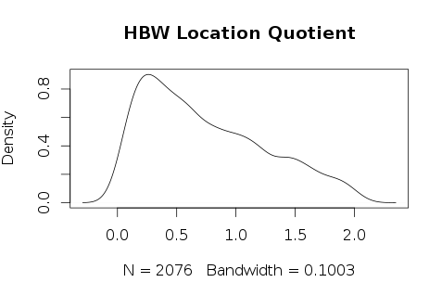

Table 1.1 HBW Location Quotient Statistical Descriptive

|  |  |  |  |  |  |
| --- | --- | --- | --- | --- | --- |
| Min | 1st Qu | Median | Mean | 3rd Qu | Max |
| 0.00758 | 0.30720 | 0.63040 | 0.74300 | 1.10400 | 2.04800 |

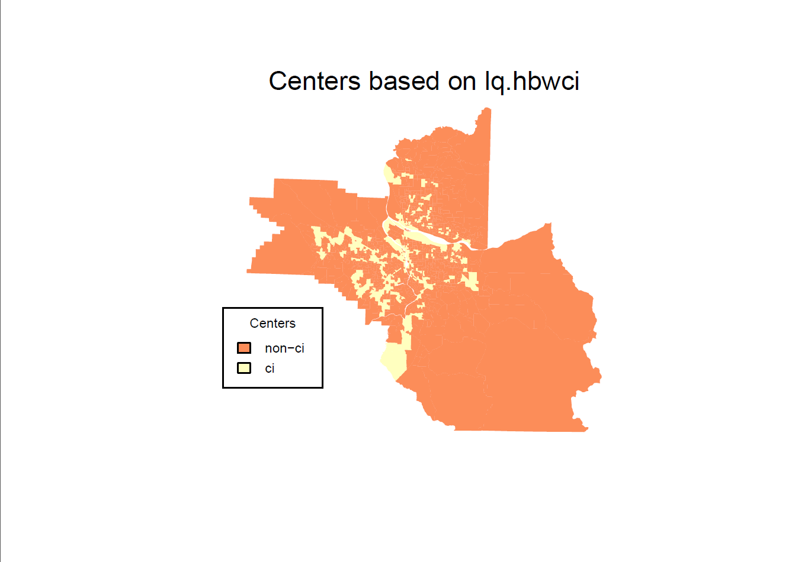

HBS Location Quotient

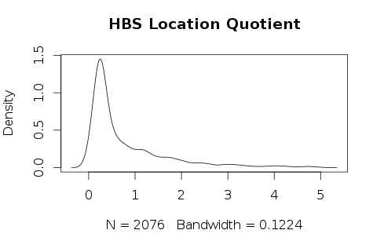

Table 1.2 HBS Location Quotient Statistical Descriptive

|  |  |  |  |  |  |
| --- | --- | --- | --- | --- | --- |
| Min | 1st Qu | Median | Mean | 3rd Qu | Max |
| 0.00093 | 0.24090 | 0.37760 | 0.79280 | 1.08100 | 4.98500 |

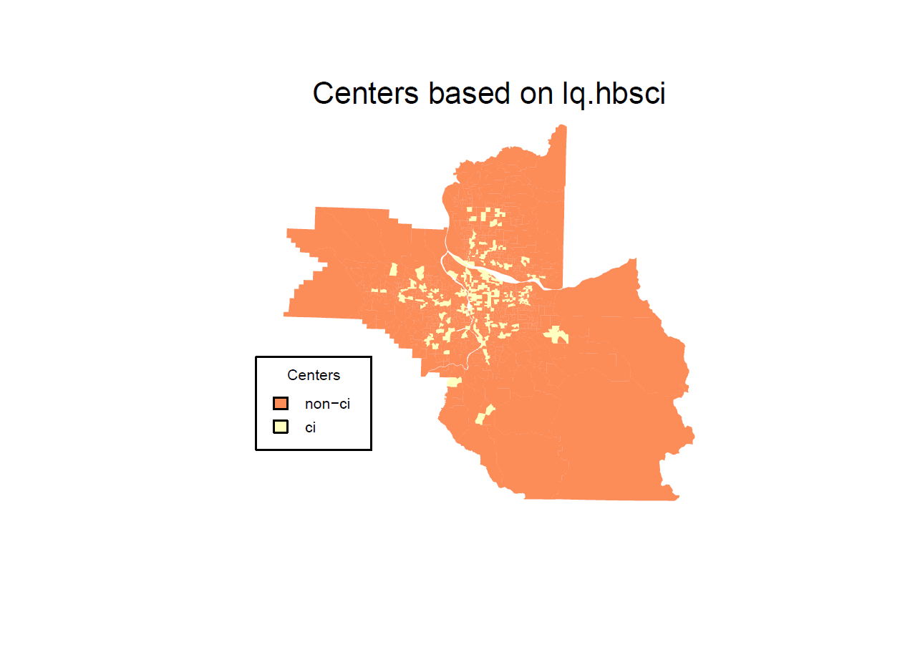

HBR Location Quotient

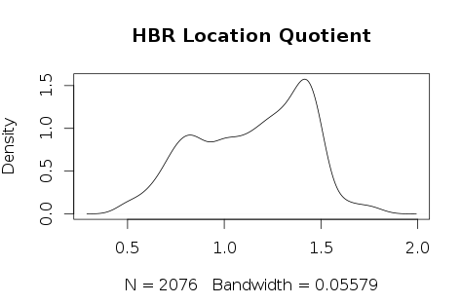

Table 1.3 HBR Location Quotient Statistical Descriptive

|  |  |  |  |  |  |
| --- | --- | --- | --- | --- | --- |
| Min | 1st Qu | Median | Mean | 3rd Qu | Max |
| 0.4575 | 0.9060 | 1.1850 | 1.1450 | 1.3860 | 1.8260 |

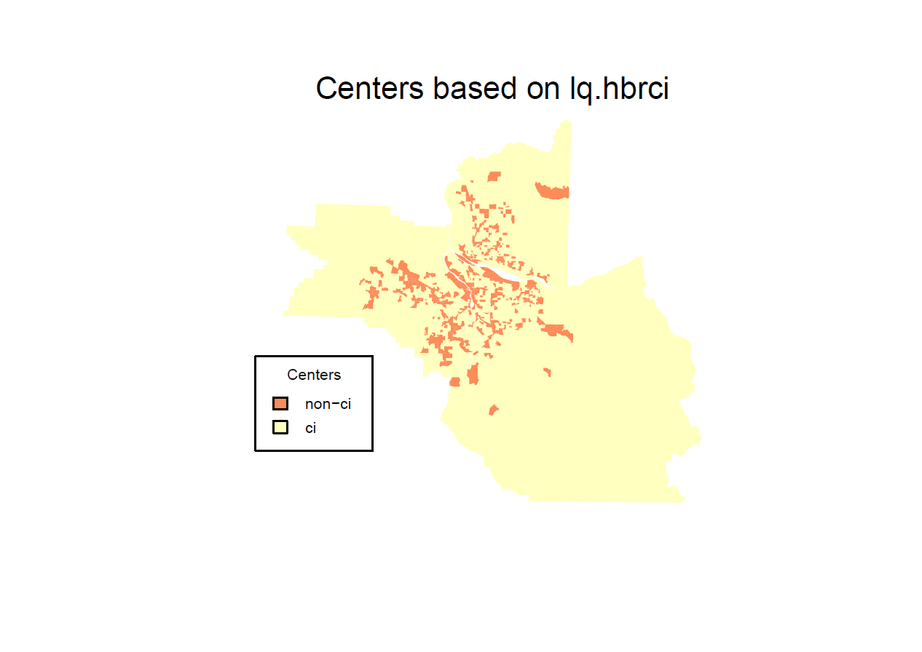

HBO Location Quotient

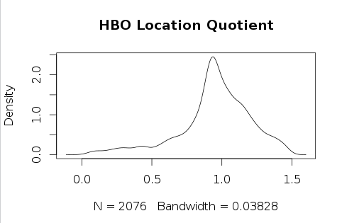

Table 1.4 HBO Location Quotient Statistical Descriptive

|  |  |  |  |  |  |
| --- | --- | --- | --- | --- | --- |
| Min | 1st Qu | Median | Mean | 3rd Qu | Max |
| 0.00275 | 0.85340 | 0.96030 | 321.500 | 1.11600 | 1.48600 |

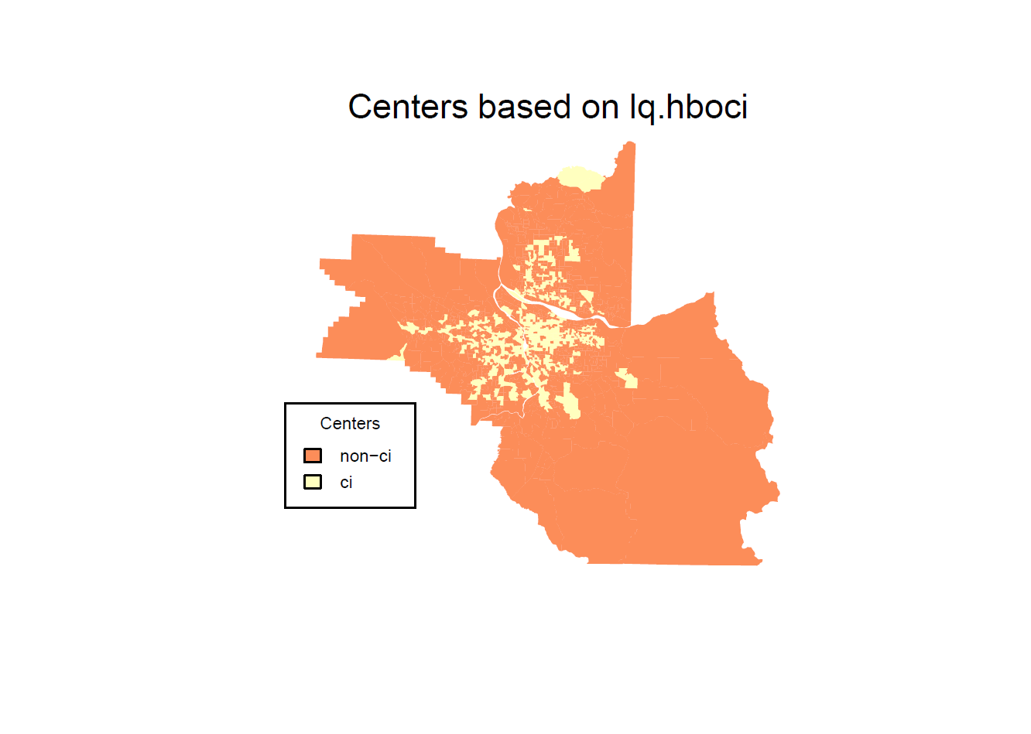

2. TDM trips approach

HBW Location Quotient

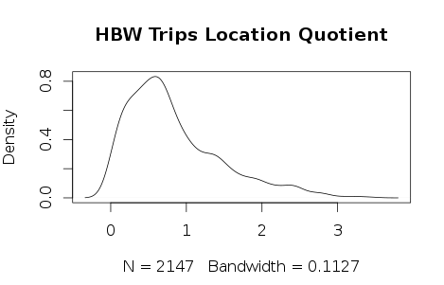

Table 2.1 HBW Location Quotient Statistical Descriptive

|  |  |  |  |  |  |
| --- | --- | --- | --- | --- | --- |
| Min | 1st Qu | Median | Mean | 3rd Qu | Max |
| 0.000 | 0.3793 | 0.6780 | 0.8382 | 1.1580 | 3.4610 |

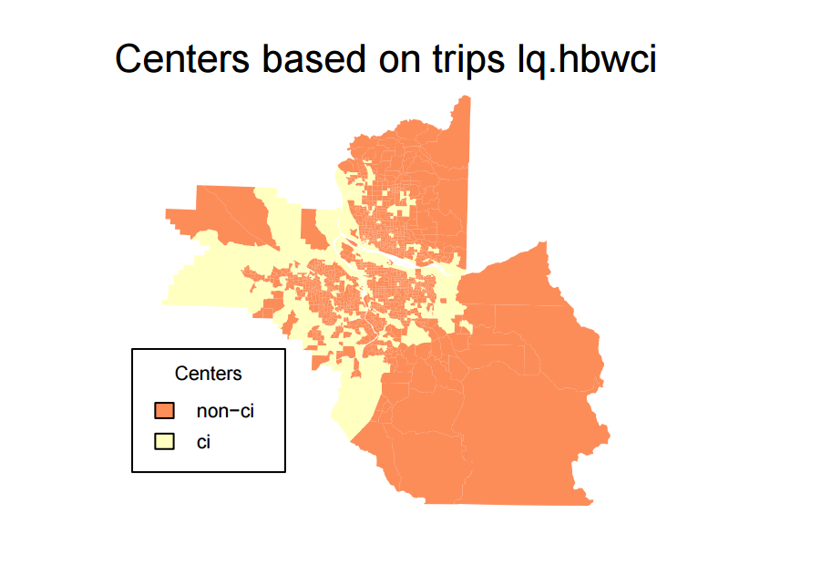

HBS Location Quotient

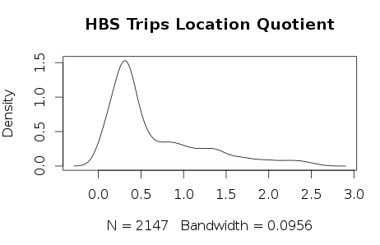

Table 2.2 HBS Location Quotient Statistical Descriptive

|  |  |  |  |  |  |
| --- | --- | --- | --- | --- | --- |
| Min | 1st Qu | Median | Mean | 3rd Qu | Max |
| 0.000 | 0.2697 | 0.3985 | 0.6534 | 0.9299 | 2.6180 |

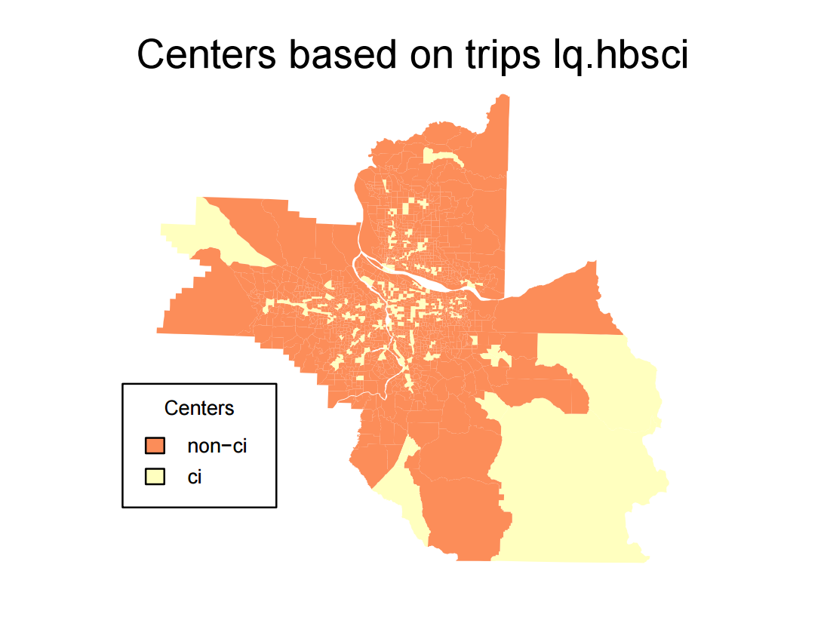

HBR Location Quotient

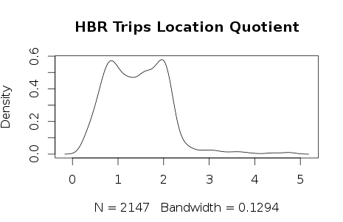

Table 2.3 HBR Location Quotient Statistical Descriptive

|  |  |  |  |  |  |
| --- | --- | --- | --- | --- | --- |
| Min | 1st Qu | Median | Mean | 3rd Qu | Max |
| 0.2219 | 0.8547 | 1.4000 | 1.4270 | 108990 | 4.7950 |

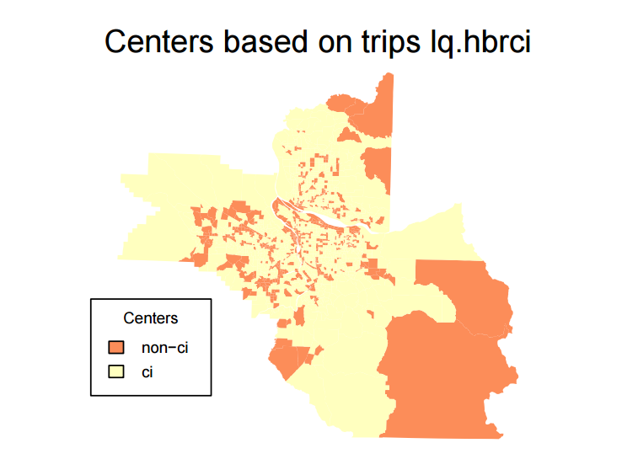

HBO Location Quotient

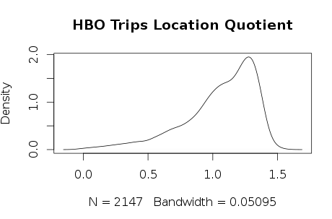

Table 2.4 HBO Location Quotient Statistical Descriptive

|  |  |  |  |  |  |
| --- | --- | --- | --- | --- | --- |
| Min | 1st Qu | Median | Mean | 3rd Qu | Max |
| 0.00275 | 0.85340 | 0.96030 | 321.500 | 1.11600 | 1.48600 |

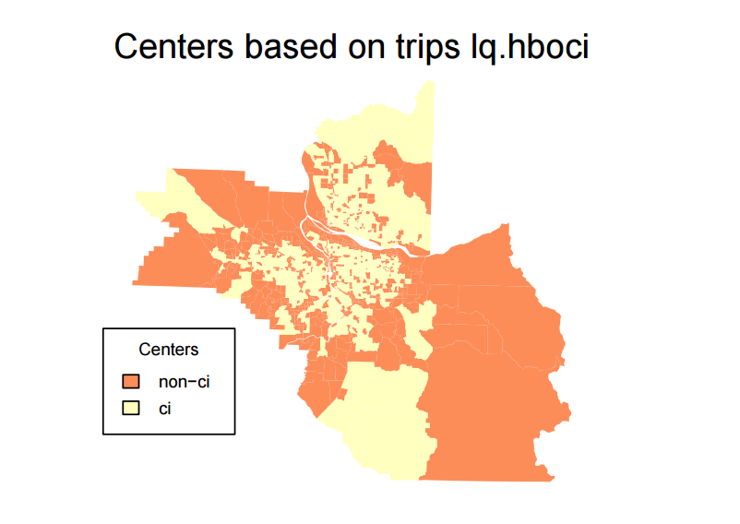

3. OHAS trip ends

HBW trips destination TAZ frequency

There are 793 HBW destination TAZs.

Table 3.1 Summary of HBW destination TAZs frequency

|  |  |  |  |  |  |
| --- | --- | --- | --- | --- | --- |
| Min | 1st Qu | Median | Mean | 3rd Qu | Max |
| 1 | 1 | 1 | 1.879 | 2 | 8 |

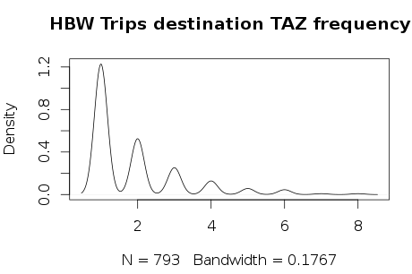

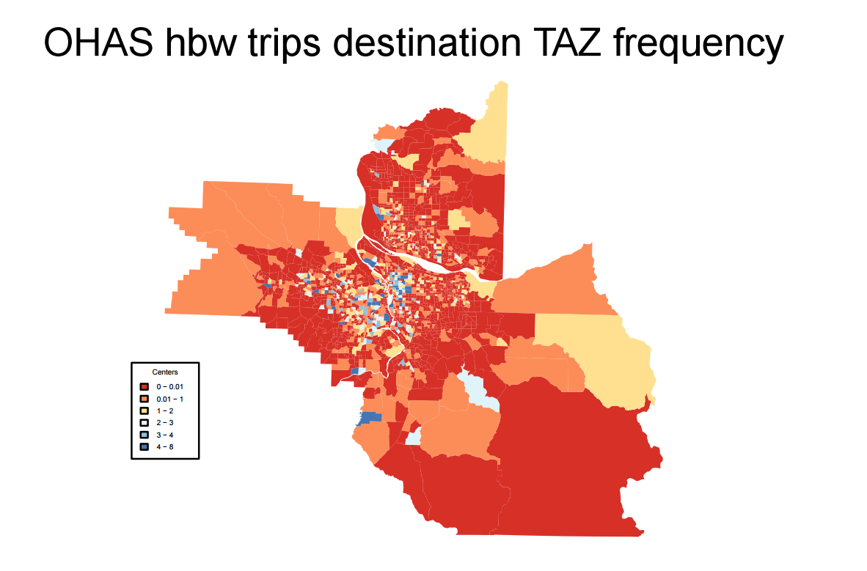

HBS trips destination TAZ frequency

There are 762 HBS destination TAZs.

Table 3.2 Summary of HBS destination TAZs frequency

|  |  |  |  |  |  |
| --- | --- | --- | --- | --- | --- |
| Min | 1st Qu | Median | Mean | 3rd Qu | Max |
| 1 | 1 | 2 | 2.56 | 3 | 23 |

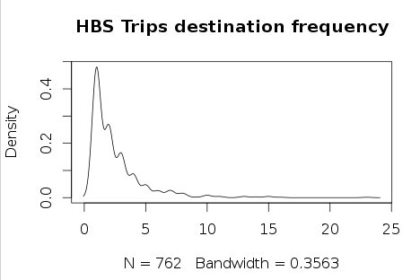

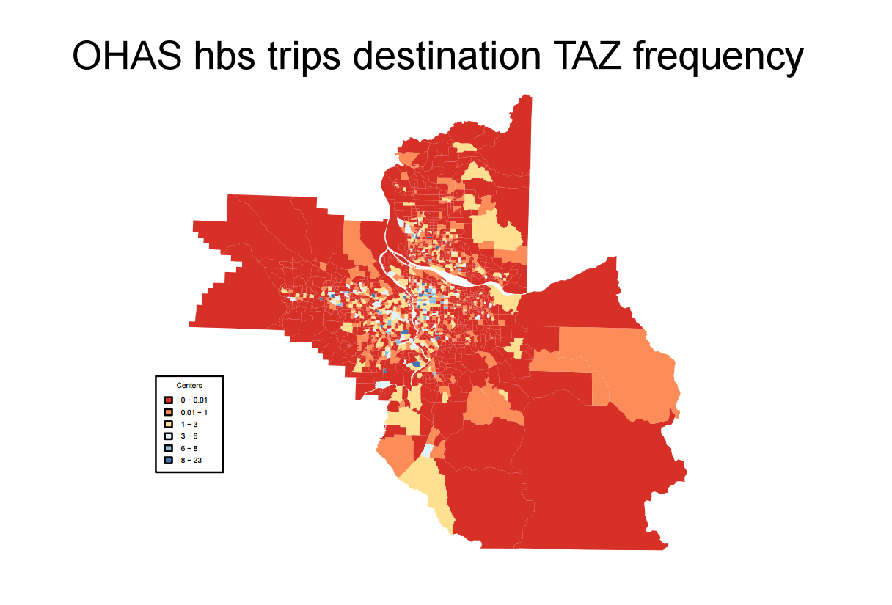

HBR trips destination TAZ frequency

There are 694 HBR destination TAZs.

Table 3.3 Summary of HBS destination TAZs frequency

|  |  |  |  |  |  |
| --- | --- | --- | --- | --- | --- |
| Min | 1st Qu | Median | Mean | 3rd Qu | Max |
| 1 | 1 | 2 | 2.421 | 3 | 20 |

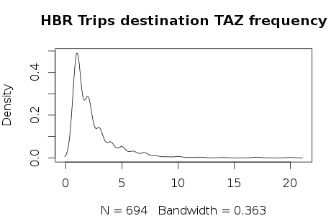

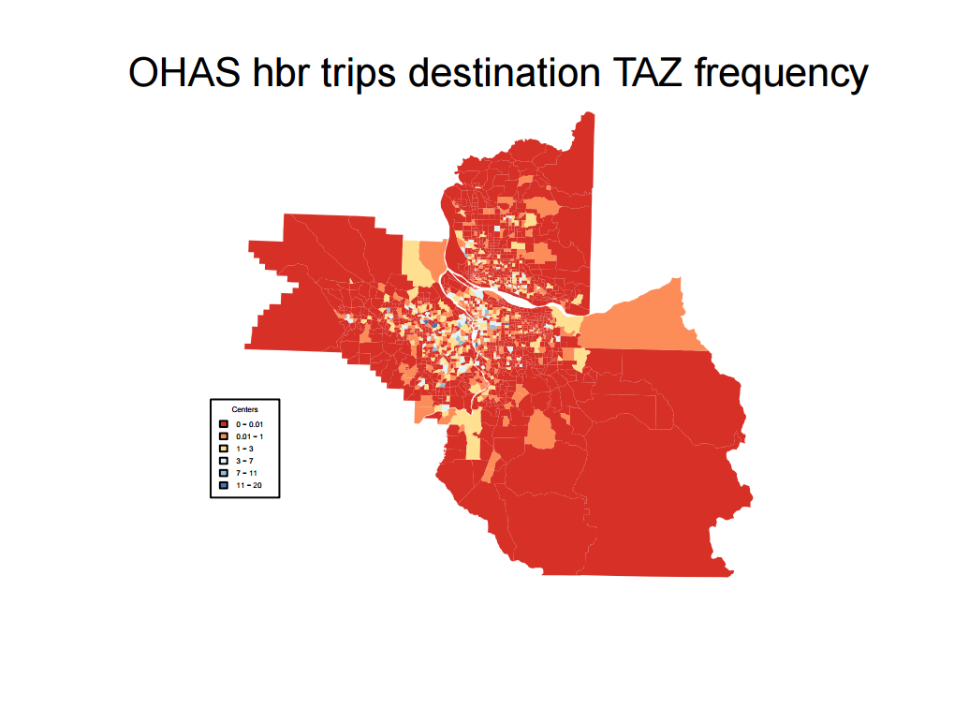

HBO trips destination TAZ frequency

There are 1455 HBR destination TAZs.

Table 3.4 Summary of HBS destination TAZs frequency

|  |  |  |  |  |  |
| --- | --- | --- | --- | --- | --- |
| Min | 1st Qu | Median | Mean | 3rd Qu | Max |
| 1 | 2 | 3 | 5.271 | 7 | 41 |

